**VIDHI ROHIRA**

**SY BTECH**

**COMPUTER ENGINEERING**

**DAA LAB 1 OUTPUTS**

**231071052**

**TEST CASE 1:-**

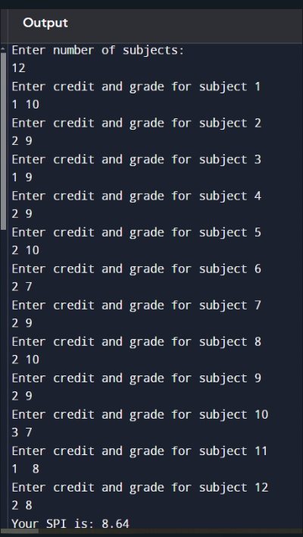

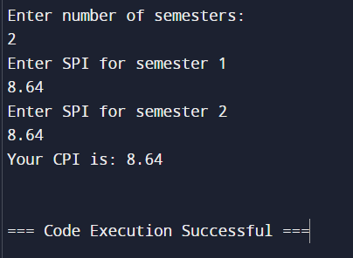

**TEST CASE 2:-**

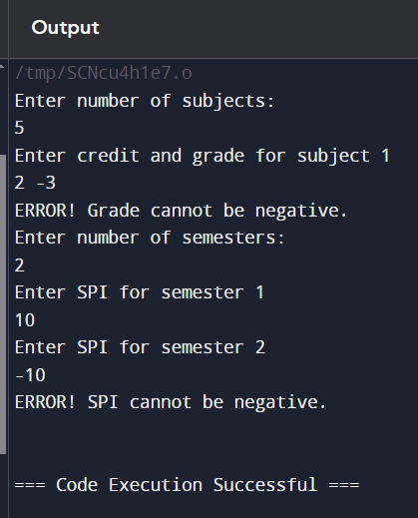

**TEST CASE 3:-**

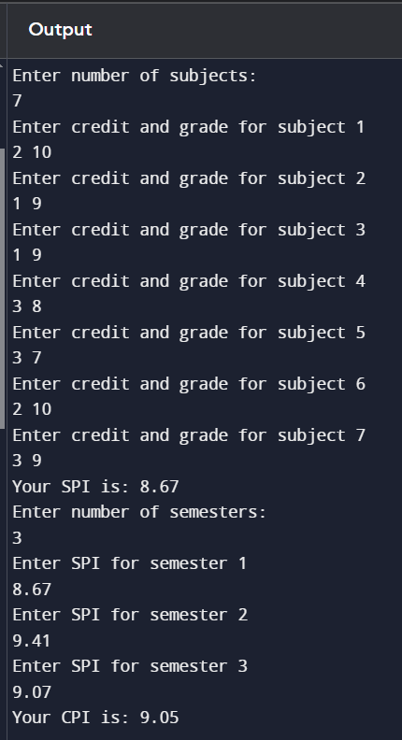

**TEST CASE 4:-**

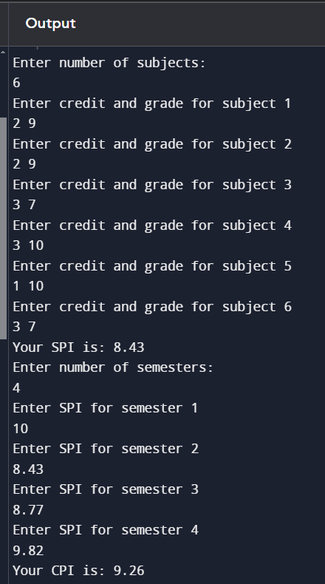

**TEST CASE 5:-**

